# Learning Outcome

# After completing this module, the student should be able to understand HyperText MarkUp Language (HTML).

To meet the learning outcome, a student has to complete the following activities

1. Create HTML document using markup Tags in HTML editor (Notepad) (Open/run the html file in web browser to check the output (30 mins)
2. Modify above HTML document using heading – paragraphs, modify above HTML document using Line Breaks, modify above HTML document using HTML Tags. (30 mins)
3. Introduce new elements of HTML5 (1 Hrs)
4. Create Text, Lists, Tables and iFrames (2 Hrs)
5. Create Hyperlinks, Images and Multimedia Working with Forms and controls. (3 Hrs)
6. Enable Hypertext Transfer Protocol (HTTP) via GET and POST requests (1 Hrs)
7. Obtain input from users. (5 Hrs)
8. Divide a webpage into logical sections (1 Hr)
9. Display computer code with HTML (1 Hr)
10. Annotation of images and graphics. (2 Hrs)
11. Marking abbreviations (1 Hr)
12. Add quotations and citations to web pages (2 Hrs)
13. Embed a webpage within another webpage (2 Hrs)

# Activity 1

## Aim: Create HTML document using mark up Tags in HTML editor (Notepad), Open/run the html file in web browser to check the output.

**Learning outcome:** HyperText MarkUp Language (HTML)

**Duration:** 30 mins

**List of Hardware/Software requirements:**

1. Windows/Ubuntu OS…...
2. Text Editors- Notepad++, Sublime Text, etc.
3. Browser

**Program 1:**

<!DOCTYPE html>

<html>

<head> <!-- Document Head Starts -->

<title>Markup Tags</title>

</head> <!-- Document Head Ends -->

<body> <!-- Document Body Starts -->

<p>My First Paragraph</p> <!--Paragraph element -->

</body> <! -- Document Body Ends -->

</html>

**Output/Results snippet:**

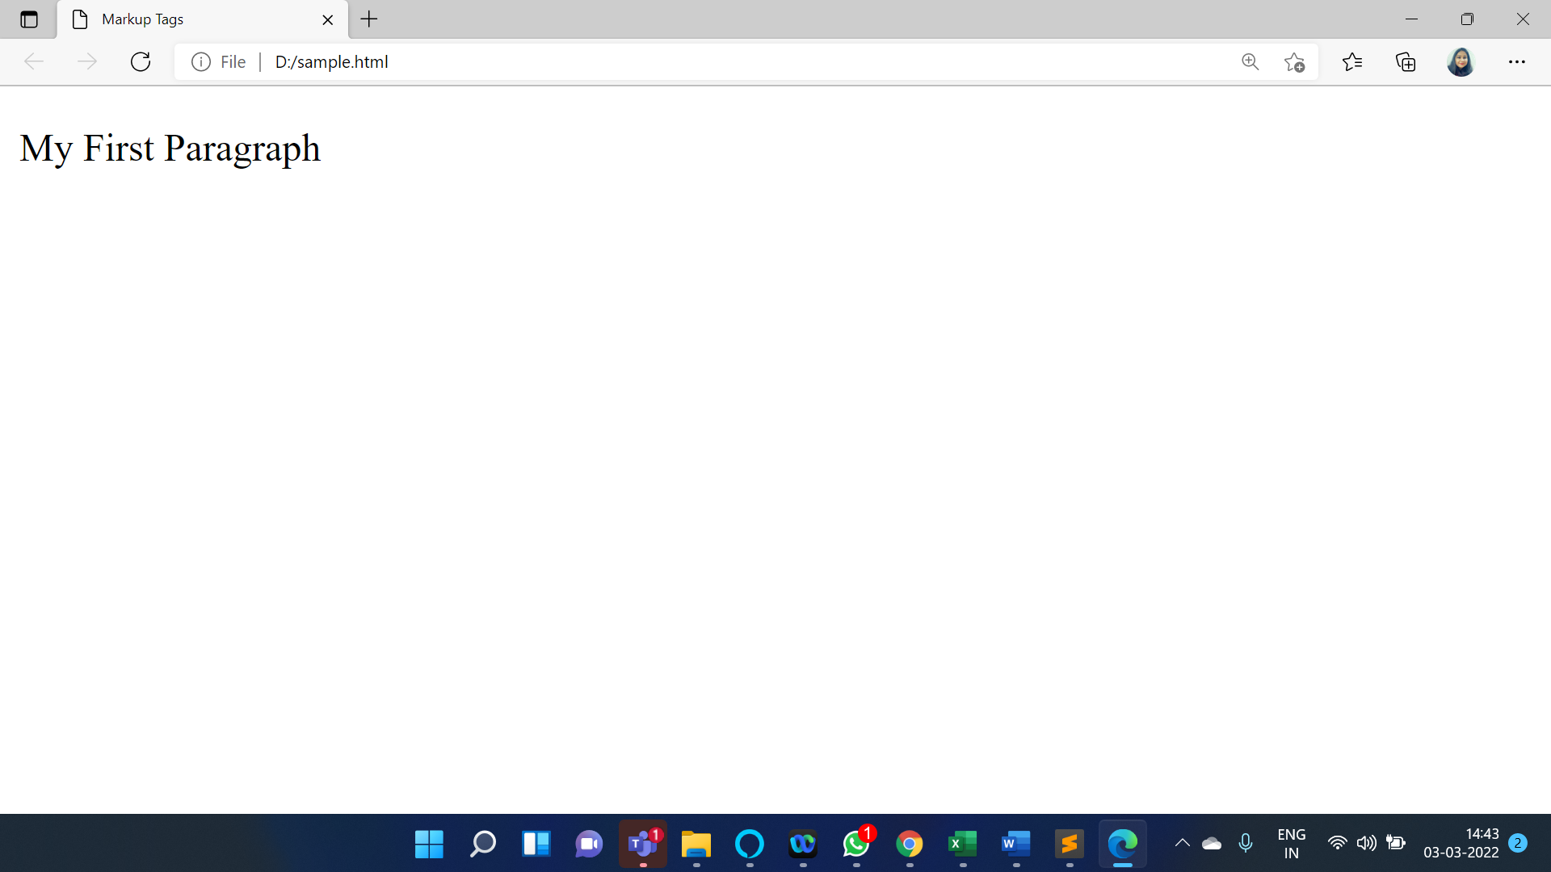

**Program 2:**

<!DOCTYPE html>

<html>

<head> <!-- Document Head Starts -->

<title>Markup Tags</title>

</head> <!-- Document Head Ends -->

<body> <!-- Document Body Starts -->

<center>

<font size="20">My Web Page</font> <!--Font element -->

</center>

</body> <! -- Document Body Ends -->

</html>

**Output/Results snippet:**

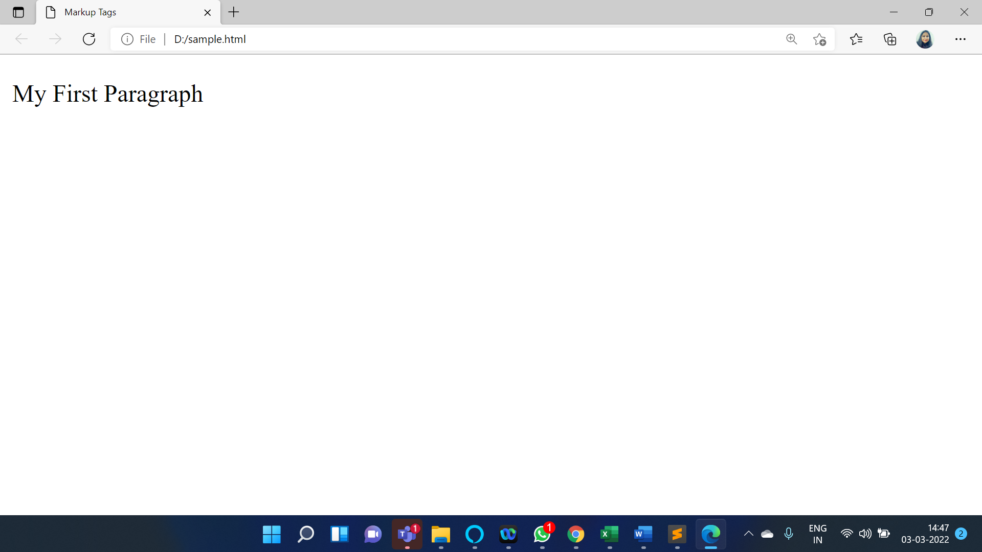

**Program 3**: Open/run the html file in web browser to check the output.

Step 1: Press "Windows-E" to launch Windows Explorer.

Step 2: Navigate to the folder that contains your HTML file.

Step 3: Double-click the file. Your default browser displays the HTML document. If the browser is not open, Windows launches it.

**Output/Results snippet:**

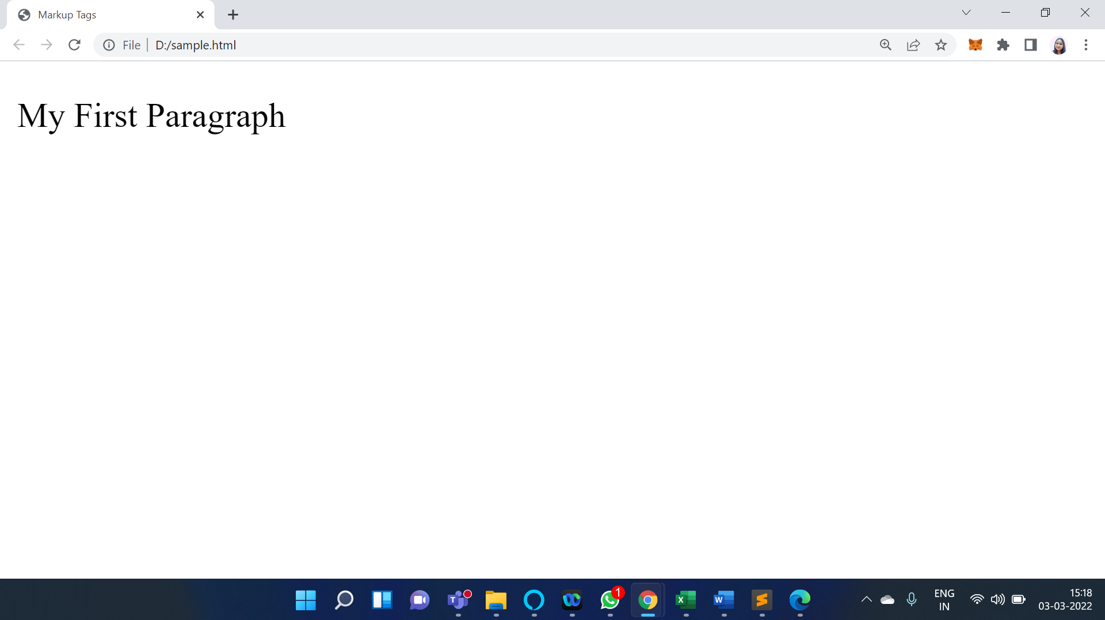

**References:**

* <https://www.w3schools.com/html/html_editors.asp>
* <https://www.tutorialrepublic.com/html-tutorial/html-get-started.php>
* <https://smallbusiness.chron.com/run-html-file-internet-browser-53175.html>
* <https://www.tutorialrepublic.com/html-tutorial/html-get-started.php>

# Activity 2

## Aim: Modify above HTML document using heading – paragraphs, Modify above HTML document using Line Breaks, Modify above HTML document using HTML Tags.

**Learning outcome:** HyperText MarkUp Language (HTML)

**Duration:** 30 mins

**List of Hardware/Software requirements:**

1. 1Windows/Ubuntu OS…...
2. Text Editors- Notepad++, Sublime Text, etc.
3. Browser

**Program 1:**

<!DOCTYPE html>

<html>

<head> <!-- Document Head Starts -->

<title> Heading & Paragraph</title>

</head> <!-- Document Head Ends -->

<body bgcolor="lightblue" > <!-- Document Body Starts -->

<h1>My First Heading</h1> <!--This is a heading-->

<h2>My First Heading</h2>

<h3>My First Heading</h3>

<h4>My First Heading</h4>

<h5>My First Heading</h5>

<h6>My First Heading</h6>

<p> <!--Paragraph element -->

HTML is a Hypertext Mark-up Language file format used as the basis of a web page.

</p>

</body> <! -- Document Body Ends -->

</html>

**Output/Results snippet:**

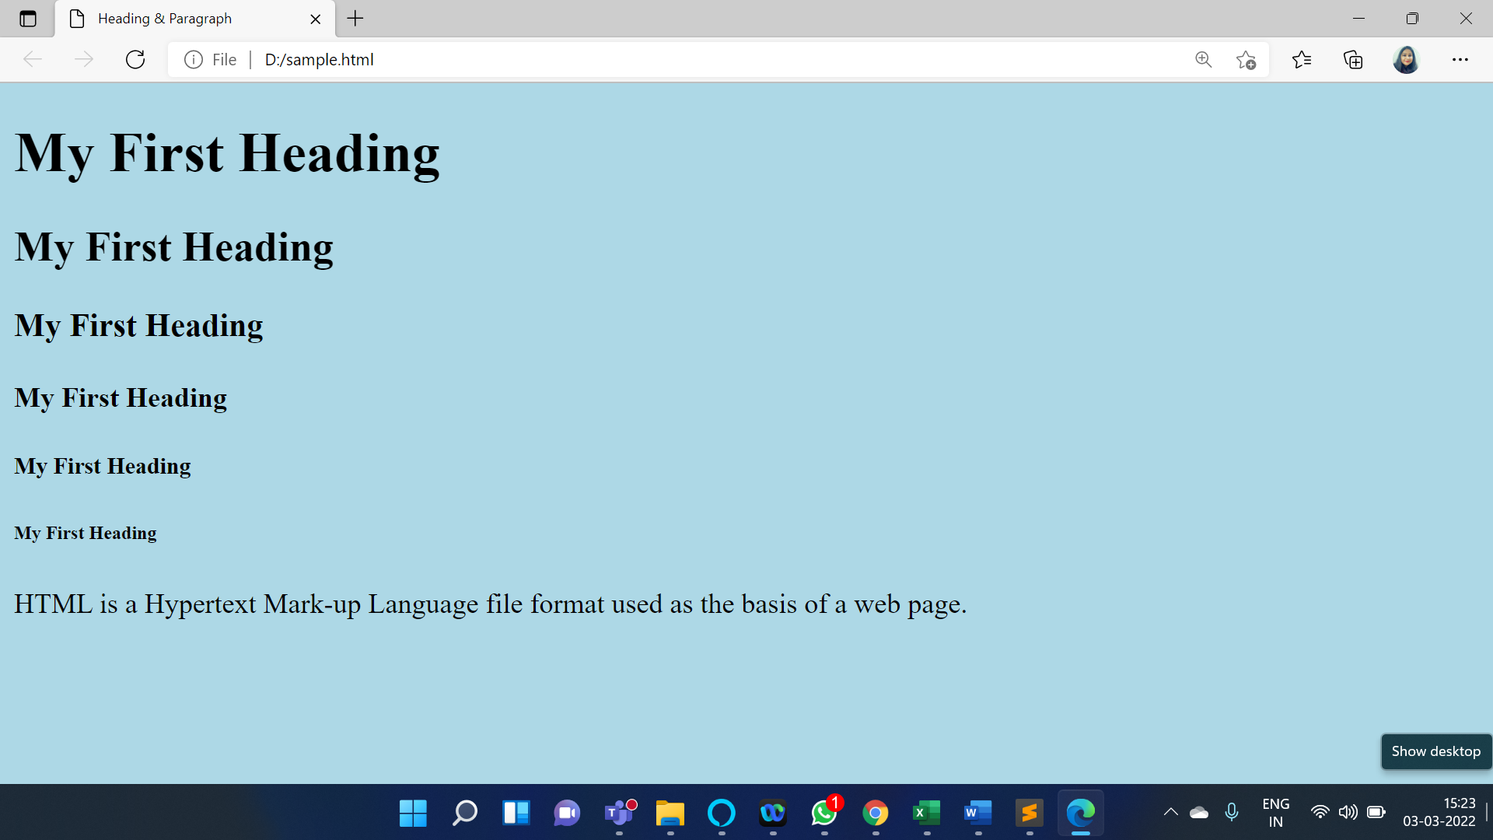

**Program 2:**

<!DOCTYPE html>

<html>

<head> <!-- Document Head Starts -->

<title> Heading Paragraph</title>

</head> <!-- Document Head Ends -->

<body > <!-- Document Body Starts -->

<p> <! – Paragraph Element with break -->

To break lines</br>in a text,</br>use the br element.

</p>

</body> <! -- Document Body Ends -->

</html>

**Output/Results snippet:**

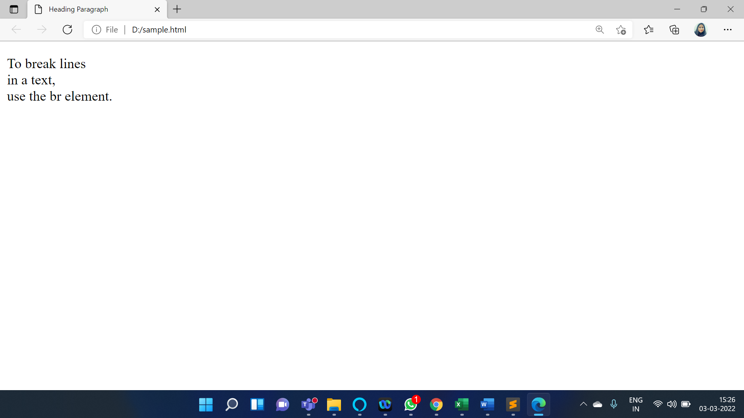

**Program 3:**

<!DOCTYPE html>

<html>

<head> <!-- Document Head Starts -->

<title> IBM </title>

</head> <!-- Document Head Ends -->

<body > <!-- Document Body Starts -->

<h1>IBM</h1> <!--Heading Tag -->

<hr> <!--Horizontal Rule -->

<p> <!--Paragraph Element -->

International Business Machines (IBM), is a global technology company that provides hardware,

software, cloud-based services and cognitive computing. </p>

<p>largest computer company in the world. </p>

</body> <! -- Document Body Ends -->

</html>

**Output/Results snippet:**

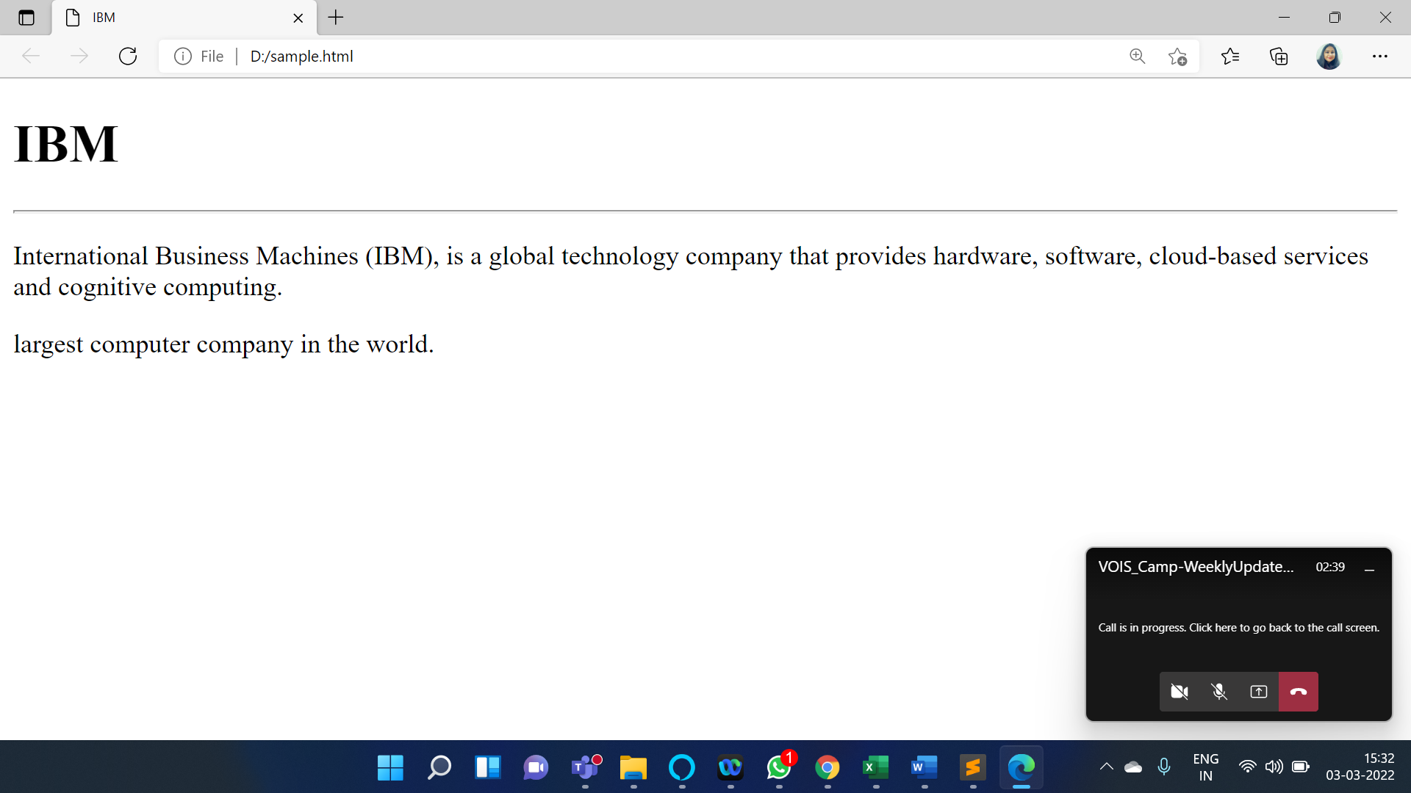

**References:**

* <https://www.w3schools.com/html/html_intro.asp>
* <https://www.tutorialrepublic.com/html-tutorial/html-paragraphs.php>
* <https://www.tutorialrepublic.com/html-tutorial/html-paragraphs.php>

# Activity 3

## Aim: Introduce new elements of HTML5

**Learning outcome:** HyperText MarkUp Language (HTML)

**Duration:** 1 Hr

**List of Hardware/Software requirements:**

1. Windows/Ubuntu OS…...
2. Text Editors- Notepad++, Sublime Text, etc.
3. Browser

**Code/Program/Procedure (with comments):**

<!DOCTYPE html>

<html>

<body>

<h2>Example of video and audio tag</h2>

<video width = "300" height = "200" controls autoplay> <!--Video Element -->

<source src = "/html5/foo.ogg" type ="video/ogg" />

<source src = "/html5/foo.mp4" type = "video/mp4" />

Your browser does not support the video element.

</video>

<audio controls autoplay> <!--Audio Element -->

<source src = "/html5/audio.ogg" type = "audio/ogg" />

<source src = "/html5/audio.wav" type = "audio/wav" />

Your browser does not support the audio element.

</audio><br>

<svg id = "svgelem" height = "100" xmlns = "http://www.abc.org/2000/svg"> <!--svg Element -->

<circle id = "redcircle" cx = "50" cy = "50 " r = "50" fill = "red" />

</svg>

<br>

<h1> HTML Nav tag</h1>

<nav> <!--Nav Element -->

<a href="/html/">HTML</a>

<a href="/css/">CSS</a>

<a href="/js/">JavaScript</a>

<a href="/jquery/">jQuery</a>

</nav>

<h1>The progress element</h1>

<label for="file">Downloading progress:</label>

<progress id="file" value="32" max="100"> 32% </progress> <!--Progress Element -->

<h2 style="font-size:25px; font-style:italic;">

Placeholder Attribute in Input Element <!--Placeholder Attribute in Input Element-->

</h2>

<form action=" ">

<input type="text" name="fname"

placeholder="First name">

<br>

<input type="text" name="lname"

placeholder="Last name">

<br>

<input type="submit" value="Submit">

</form>

</body>

</html>

**Output/Results snippet:**

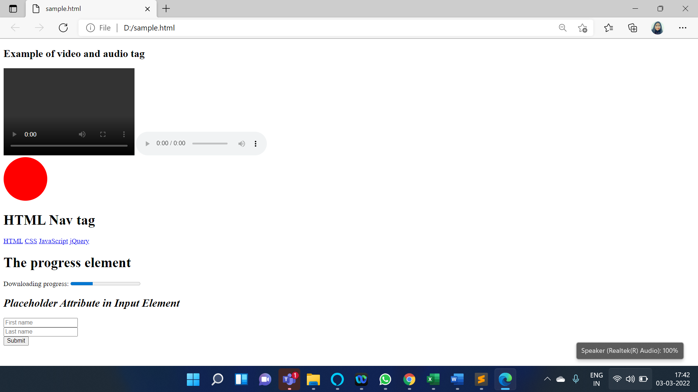

**References:**

* <https://www.w3.org/wiki/HTML/New_HTML5_Elements>
* <https://www.geeksforgeeks.org/html5-new-tags/>
* <https://www.javatpoint.com/html-new-elements>

# Activity 4

## Aim: Create Text, Lists, Tables and iFrames

**Learning outcome:** HyperText MarkUp Language (HTML)

**Duration:** 2 Hrs

**List of Hardware/Software requirements:**

1. Windows/Ubuntu OS…...
2. Text Editors- Notepad++, Sublime Text, etc.
3. Browser

**Program 1:** A simple HTML webpage with the body Texts.

<!DOCTYPE html>

<html>

<head> <!-- Document Head Starts -->

<title> Text,Lists,Tables and Frames </title>

</head> <! -- Document Head Ends -->

<body > <!-- Document Body Starts -->

<b>Bold text.</b><br> <!-- This text is Bold -->

<i>Italic text.</i><br> <!-- This text is Italic -->

<pre>Preformatted text <!-- This text is Preformatted text -->

displays just

as you

type it...

...line breaks,

spaces...

...and all!

</pre>

<tt>Teletype text - sometimes referred to as typewriter text.</tt><br> <!-- This text is Teletype Text-->

<cite>Citation text.</cite><br> <!-- This text is Citation -->

<em>Emphasized text.</em><br> <!-- This text is Emphasize -->

<code>Code text.</code><br> <!-- This text is Codetext -->

<big>Big text.</big><br> <!-- This text is Big -->

<small>Small text.</small><br> <!-- This text is Small -->

<del>Delete this text.</del><br> <!-- This text is Delete Text -->

<ins>Insert this text.</ins><br> <!-- This text is Insertion -->

<kbd>Keyboard text - text to be entered by the user.</kbd><br> <!-- This text is Keyboard text-->

<q>Quotation text.</q><br> <!-- This text is Quotation text -->

<samp>Sample text (output from a computer program).</samp><br> <!-- This text is Sample Text-->

<var>Variable text.</var><br> <!-- This text is Variable Text -->

<dfn>Definition.</dfn>: To define the meaning of a word, phrase or term. <! -- This text is Document Type Definition -->

</body> <! -- Document Body Ends -->

</html>

**Output/Results snippet:**

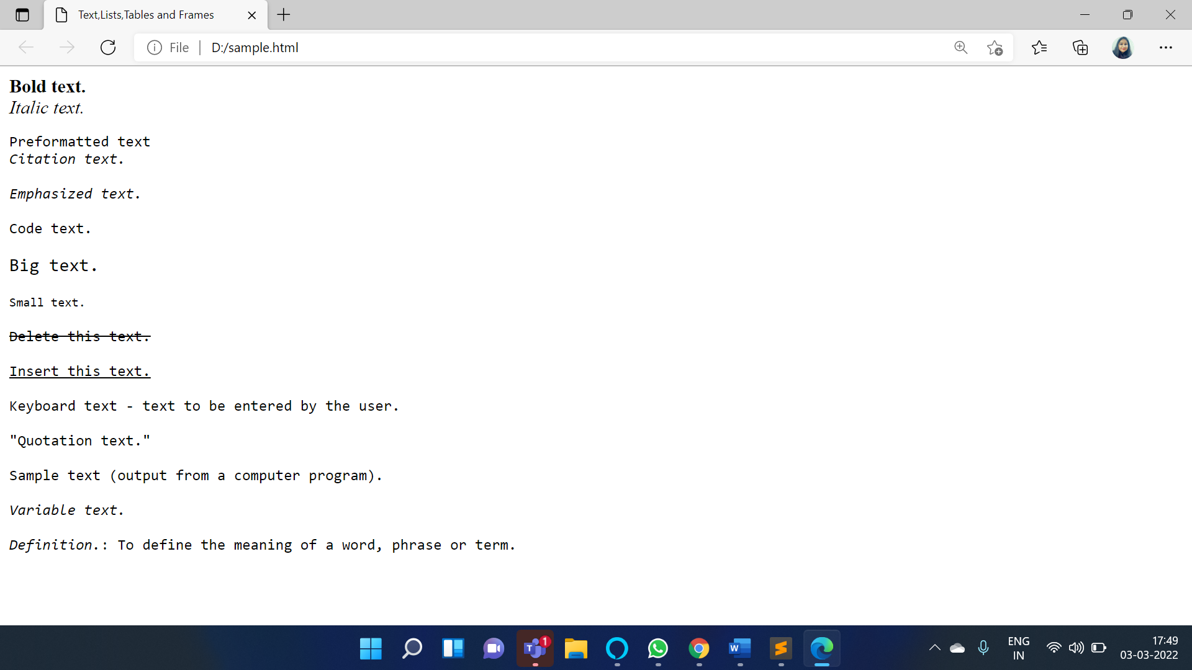

**Program 2:** A simple HTML webpage with the body Tables.

<!DOCTYPE html>

<html>

<head> <!-- Document Head Starts -->

<title> Tables </title>

</head> <! -- Document Head Ends -->

<body > <!-- Document Body Starts -->

<table class="example3" border="2"> <!--Table Tag Starts -->

<tr> <!--Table Row Starts -->

<th colspan="2">Table header</th> <!--This is Table Head -->

</tr> <!--Table Row Ends -->

<tr> <!--Table Row Starts -->

<td width="20%">Table cell 1</td><td>Table cell 2</td>

</tr> <!--Table Row Ends -->

</table><br> <!--Table Tag Ends -->

<table class="example4" border="2"> <!--Table Tag Starts -->

<tr> <!--Table Row Starts -->

<th rowspan="2" width="25%">Table header</th> <!--This is Table Head -->

<td width="30%">Table cell 1</td> <!--This is Table Data -->

</tr> <!--Table Row Ends -->

<tr> <!--Table Row Starts -->

<td width="30%">Table cell 2</td> <!--This is Table Data -->

</tr> <!--Table Row Ends -->

</table> <!—Table Tag Ends -->

</body> <! -- Document Body Ends -->

</html>

**Output/Results snippet:**

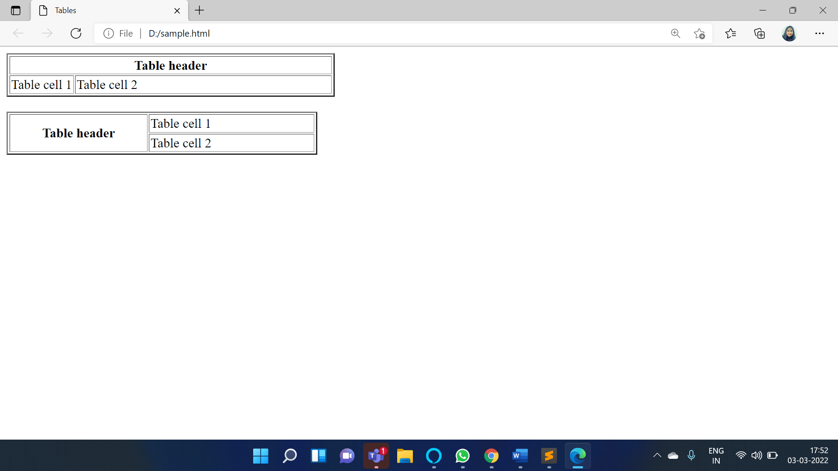

**Program 3:** A simple HTML webpage with the body List.

<!DOCTYPE html>

<html>

<head> <!-- Document Head Starts -->

<title> Lists </title>

</head> <! -- Document Head Ends -->

<body> <!-- Document Body Starts -->

<ol> <!-- OrderedList Starts -->

<li>List item 1</li> <!--List of Items -->

<li>List item 2</li>

<li>List item 3</li>

</ol> <! -- OrderedList Ends -->

<ul> <!-- UnOrderedList Starts -->

<li>List item 1</li> <!--List of Items -->

<li>List item 2</li>

<li>List item 3</li>

</ul> <! -- UnOrderedList Ends-->

<dl> <!—This is Definition List Starts-->

<dt>Term 1</dt> <!—This is Definition Term -->

<dd>Definition of term 1</dd> <!—This is Definition Data -->

<dt>Term 2</dt> <!—This is Definition Term -->

<dd>Definition of term 2</dd> <!—This is Definition Data -->

</dl> <!--This is Definition List Ends-->

</body> <! -- Document Body Ends -->

</html>

**Output/Results snippet:**

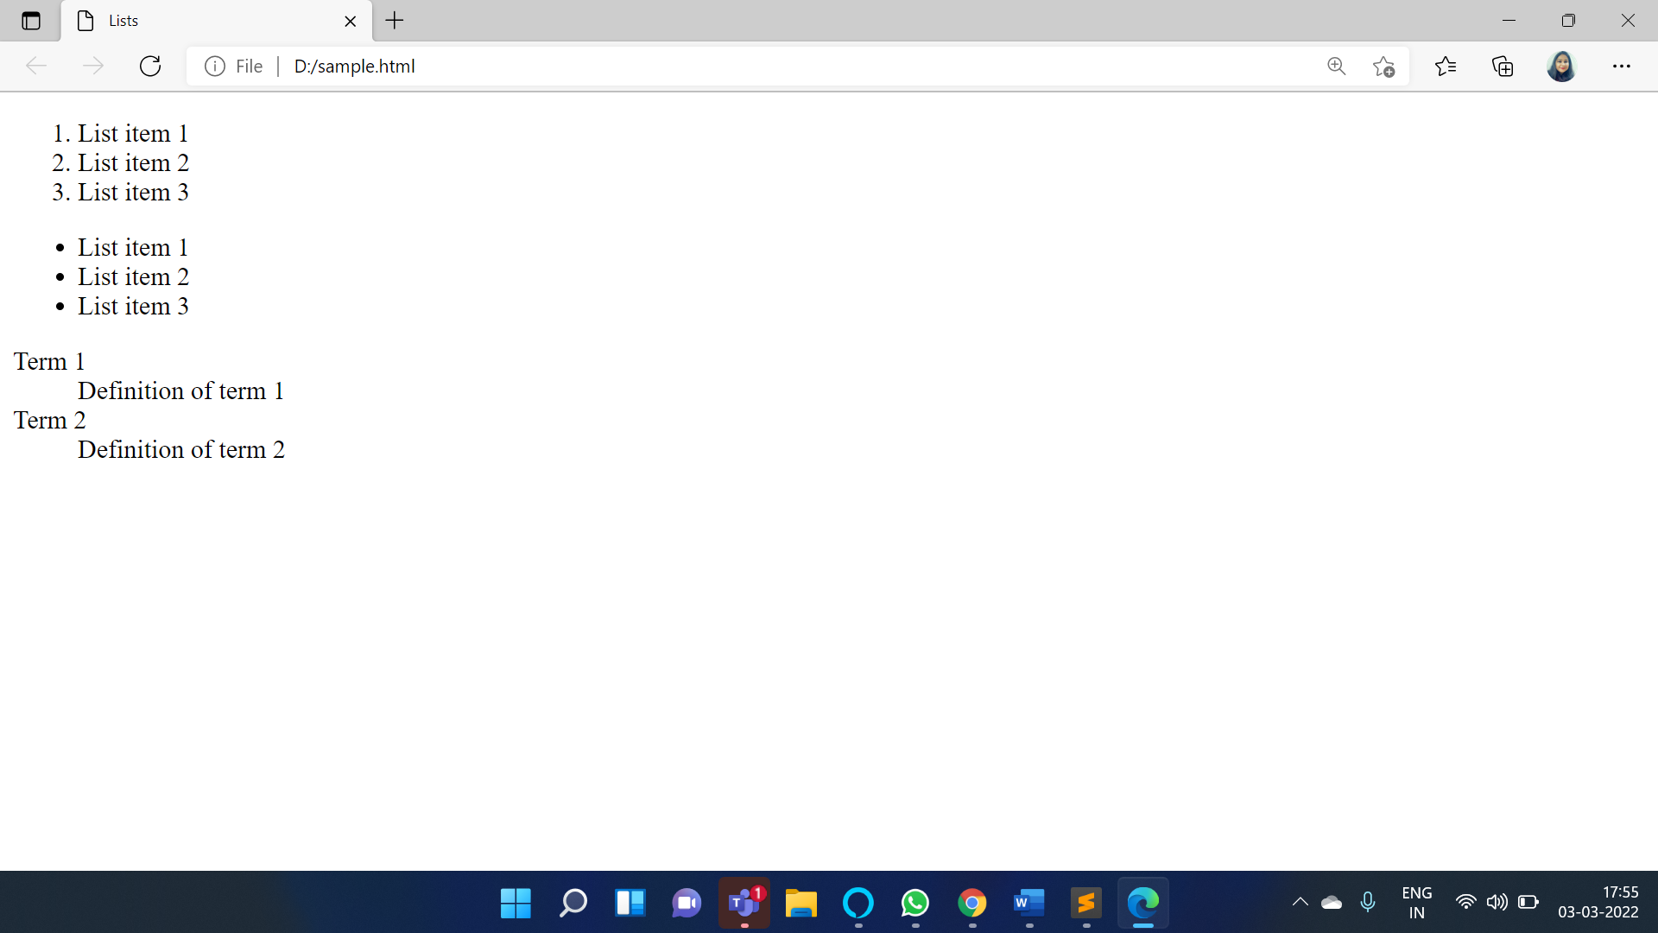

**Program 3:** A simple HTML webpage with the body Frames.

<!DOCTYPE html>

<html>

<head> <! -- Document Head Starts -->

<title>Frame tag</title>

</head> <! -- Document Head Ends -->

<frameset cols="25%,50%,25%"> <! -- Frameset Starts -->

<frame src="frame1.html" > <!--Frame element -->

<frame src="frame2.html"> <!--Frame element -->

<frame src="frame3.html"> <!--Frame element -->

</frameset> <! -- Frameset Ends -->

</html>

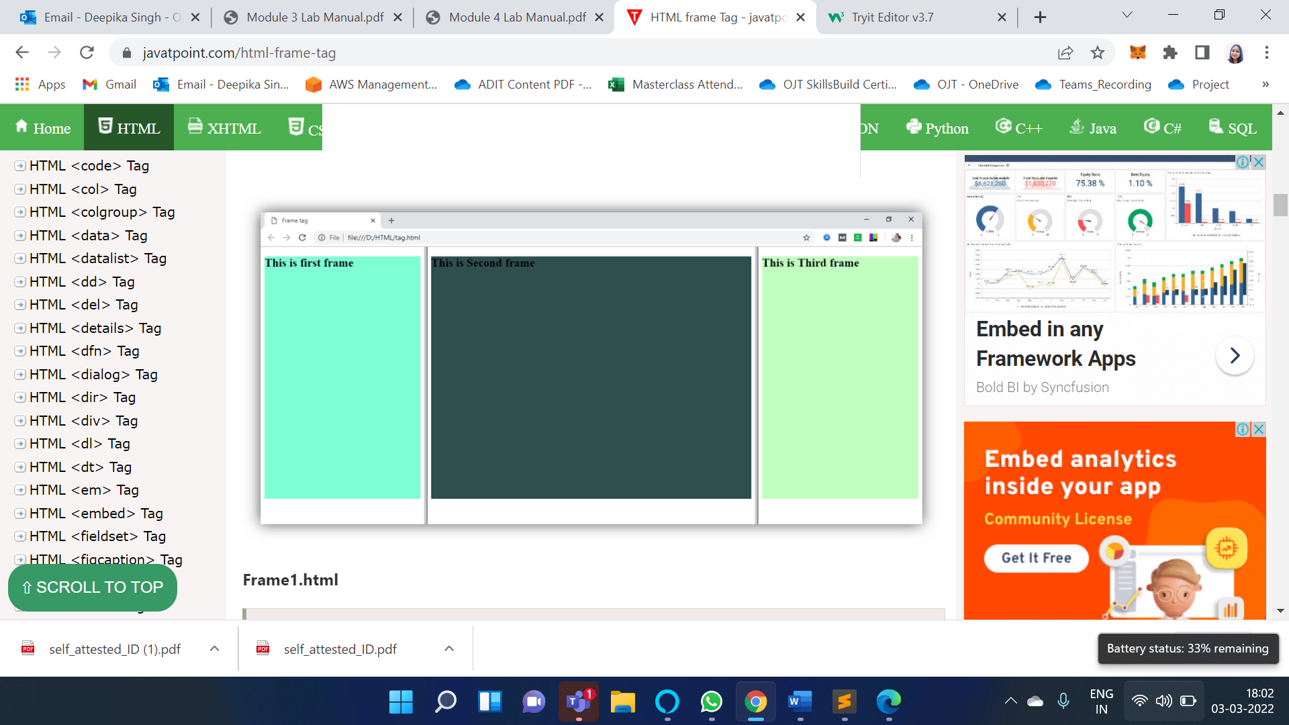

**References:**

* <https://www.w3.org/TR/html4/present/frames.html>
* <https://www.javatpoint.com/html-tags>
* <https://www.w3schools.com/html/html_iframe.asp>

# Activity 5

## Aim: Create Hyperlinks, Images and Multimedia Working with Forms and controls.

**Learning outcome:** HyperText MarkUp Language (HTML)

**Duration:** 3 Hrs

**List of Hardware/Software requirements:**

1. Windows/Ubuntu OS…...
2. Text Editors- Notepad++, Sublime Text, etc.
3. Browser

**Program 1:** Create Hyperlinks, Images and Multimedia

<!DOCTYPE html>

<html>

<head> <!-- Document Head Starts -->

<title> Links with Paragraph</title>

</head> <! -- Document Head Ends -->

<body> <!-- Document Body Starts -->

<a href="https://www.google.com">Welcome to HTML</a></br>

<!--This is Hyperlink -->

<p>Locked in a frame? <a href="https://edunetworld.com/" target="_top">Click here!</a></p>

<!--This is Paragraph with Hyperlink -->

<br>

<a href="http://www.google.com">

<img src="../spring.png" width="300" height="200" alt="HTML tutorial"></a>

<br>

<video width = "300" height = "200" controls autoplay> <!-- video Element Starts-->

<source src = "../video.mp4" type="video/mp4" />Your browser does not support the

<video> element.

</video> <!-- video Element Ends-->

</body> <! -- Document Body Ends -->

</html>

**Output/Results snippet:**

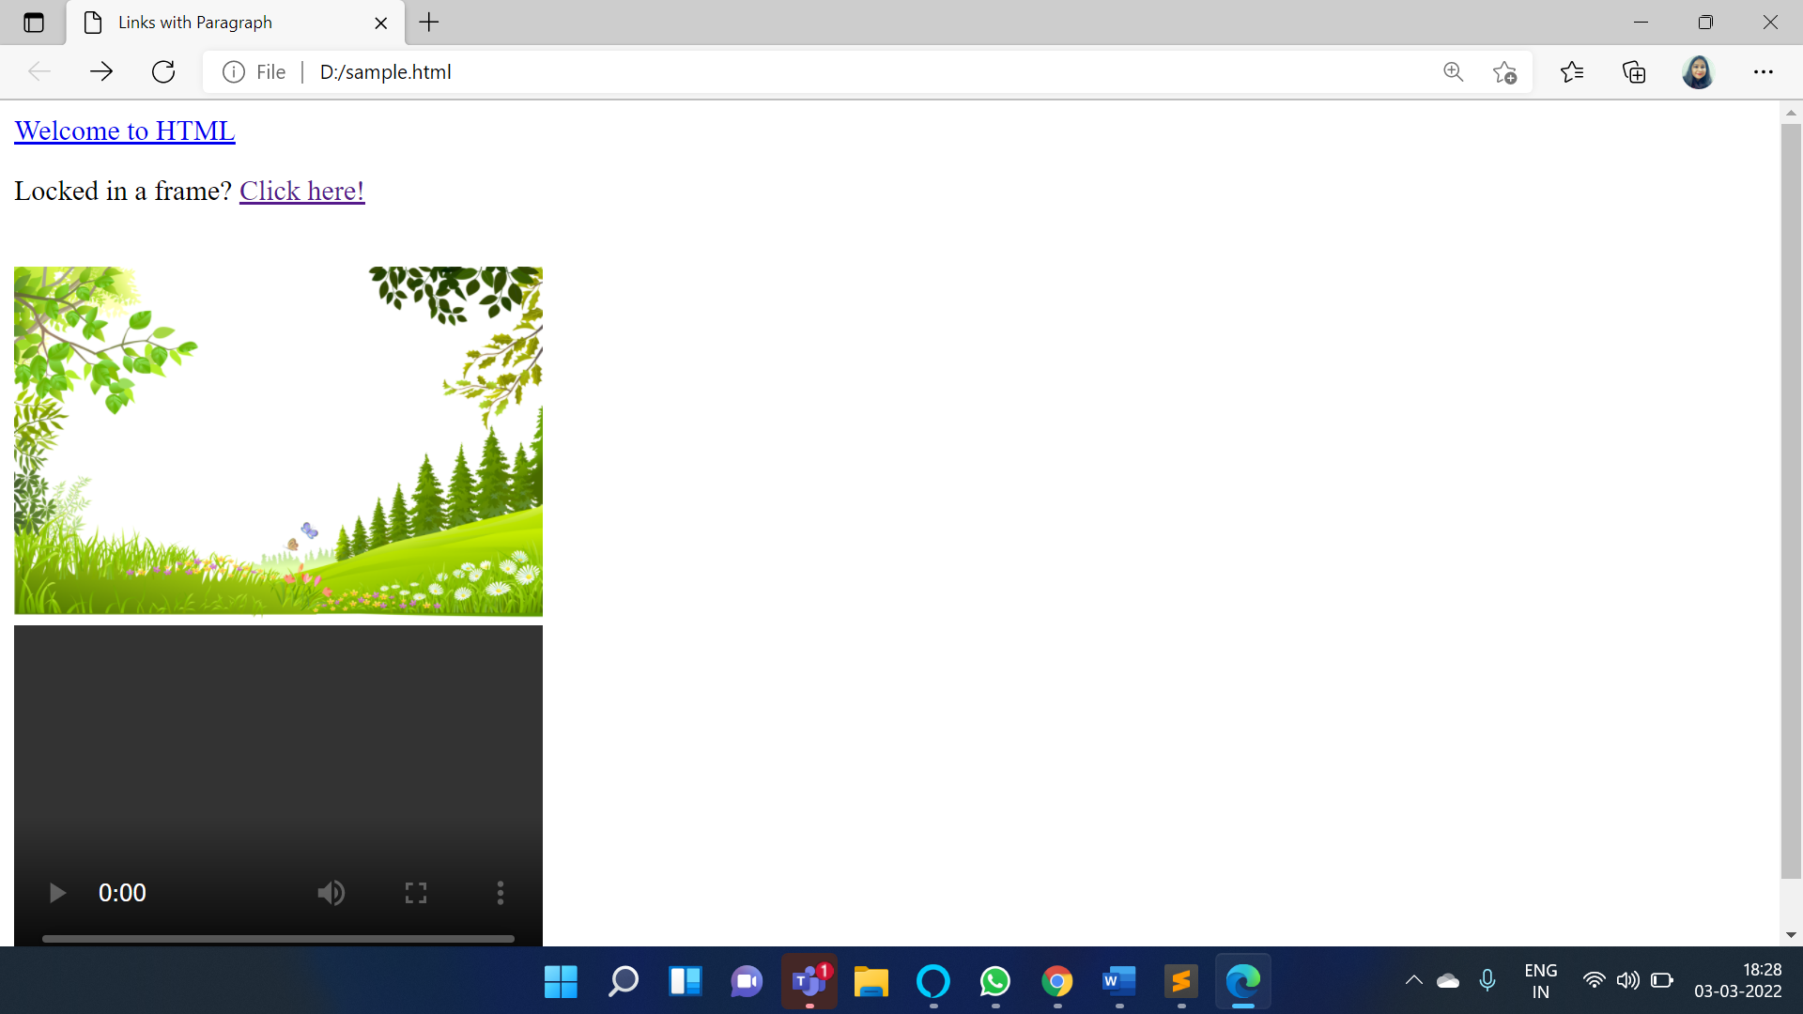

**Program 2:** Working with forms and controls

<!DOCTYPE html>

<html>

<head> <!-- Document Head Starts -->

<title> Forms and Controls</title>

</head> <!-- Document Head Ends -->

<body> <!-- Document Body Starts -->

<form> <!-- Form Element Starts -->

<table cellpadding="2" width="20%" bgcolor="lightblue" align="center" cellspacing="2"> <!--Table Tag Starts -->

<tr> <!--Table Row Starts -->

<td colspan=2> <!--This is Table Data -->

<center><font size=4><b>Student Registration Form</b></font></center> <!--This is font-->

</td>

</tr> <!--Table Row Ends -->

<tr> <!--Table Row Starts -->

<td>Name</td> <!--This is Table Data -->

<td><input type=”text” name=textnames id="textname" size="30"></td> <!--This is Textbox-->

</tr> <!--Table Row Ends -->

<tr> <!--Table Row Starts -->

<td>Father Name</td> <!--This is Table Data -->

<td><input type="text" name="fathername" id="fathername" size="30"></td> <!--This is Textbox-->

</tr> <!--Table Row Ends -->

<tr> <!--Table Row Starts -->

<td>Postal Address</td> <!--This is Table Data -->

<td><input type="text" name="paddress" id="paddress" size="30"></td> <!--This is Textbox-->

</tr> <!--Table Row Ends -->

<tr> <!--Table Row Starts -->

<td>Personal Address</td> <!--This is Table Data -->

<td><input type="text" name="personaladdress" id="personaladdress" size="30"></td>> <!--This is Textbox-->

</tr> <!--Table Row Ends -->

<tr> <!--Table Row Starts -->

<td>Sex</td> <!--This is Table Data -->

<td><input type="radio" name="sex" value="male" size="10">Male <!--This is Table Data --> <!--Input type is radio-->

<input type="radio" name="sex" value="Female" size="10">Female</td>

</tr> <!--Table Row Ends -->

<tr> <!--Table Row Starts -->

<td>City</td> <!--This is Table Data -->

<td><select name="City"> <! This is Dropdown List-->

<option value="-1" selected>select..</option> <!--This is option for Cities-->

<option value="New Delhi">NEW DELHI</option>

<option value="Mumbai">MUMBAI</option>

<option value="Goa">GOA</option>

<option value="Patna">PATNA</option>

</select></td>

</tr> <!--Table Row Ends -->

<tr> <!--Table Row Starts -->

<td>Course</td> <!--This is Table Data -->

<td><select name="Course"> <! This is Dropdown List-->

<option value="-1" selected>select..</option> <!--This is option for Course-->

<option value="B.Tech">B.TECH</option>

<option value="MCA">MCA</option>

<option value="MBA">MBA</option>

<option value="BCA">BCA</option>

</select></td>

</tr> <!--Table Row Ends -->

<tr> <!--Table Row Starts -->

<td>District</td> <!--This is Table Data -->

<td><select name="District"> <! This is Dropdown List-->

<option value="-1" selected>select..</option>> <!--This is option for Districts-->

<option value="Nalanda">NALANDA</option>

<option value="UP">UP</option>

<option value="Goa">GOA</option>

<option value="Patna">PATNA</option>

</select></td>

</tr> <!--Table Row Ends -->

<tr> <!--Table Row Starts -->

<td>State</td> <!--This is Table Data -->

<td><select Name="State"> <! This is Dropdown List-->

<option value="-1" selected>select..</option> <!--This is option for States-->

<option value="New Delhi">NEW DELHI</option>

<option value="Mumbai">MUMBAI</option>

<option value="Goa">GOA</option>

<option value="Bihar">BIHAR</option>

</select></td>

</tr> <!--Table Row Ends -->

<tr> <!--Table Row Starts -->

<td>PinCode</td> <!--This is Table Data -->

<td><input type="text" name="pincode" id="pincode" size="30"></td> <!—This is Textbox-->

</tr> <!--Table Row Ends -->

<tr> <!--Table Row Starts -->

<td>EmailId</td> <!--This is Table Data -->

<td><input type="text" name="emailid" id="emailid" size="30"></td> <!—This is Textbox-->

</tr> <!--Table Row Ends -->

<tr> <!--Table Row Starts -->

<td>DOB</td> <!--This is Table Data -->

<td><input type="text" name="dob" id="dob" size="30"></td> <!—This is Textbox-->

</tr> <!--Table Row Ends -->

<tr> <!--Table Row Starts -->

<td>MobileNo</td> <!--This is Table Data -->

<td><input type="text" name="mobileno" id="mobileno" size="30"></td> <!—This is Textbox-->

</tr> <!--Table Row Ends -->

<tr> <!--Table Row Starts -->

<td><input type="reset"></td> <!--This is Table Data & Reset button-->

<td colspan="2"><input type="submit" value="Submit Form" /></td> <!--submit button-->

</tr> <!--Table Row Ends -->

</table> <!--Table Tag Ends-->

</form> <! -- Form Element Ends -->

</body> <! -- Document Body Ends -->

</html>

**Output/Results snippet:**

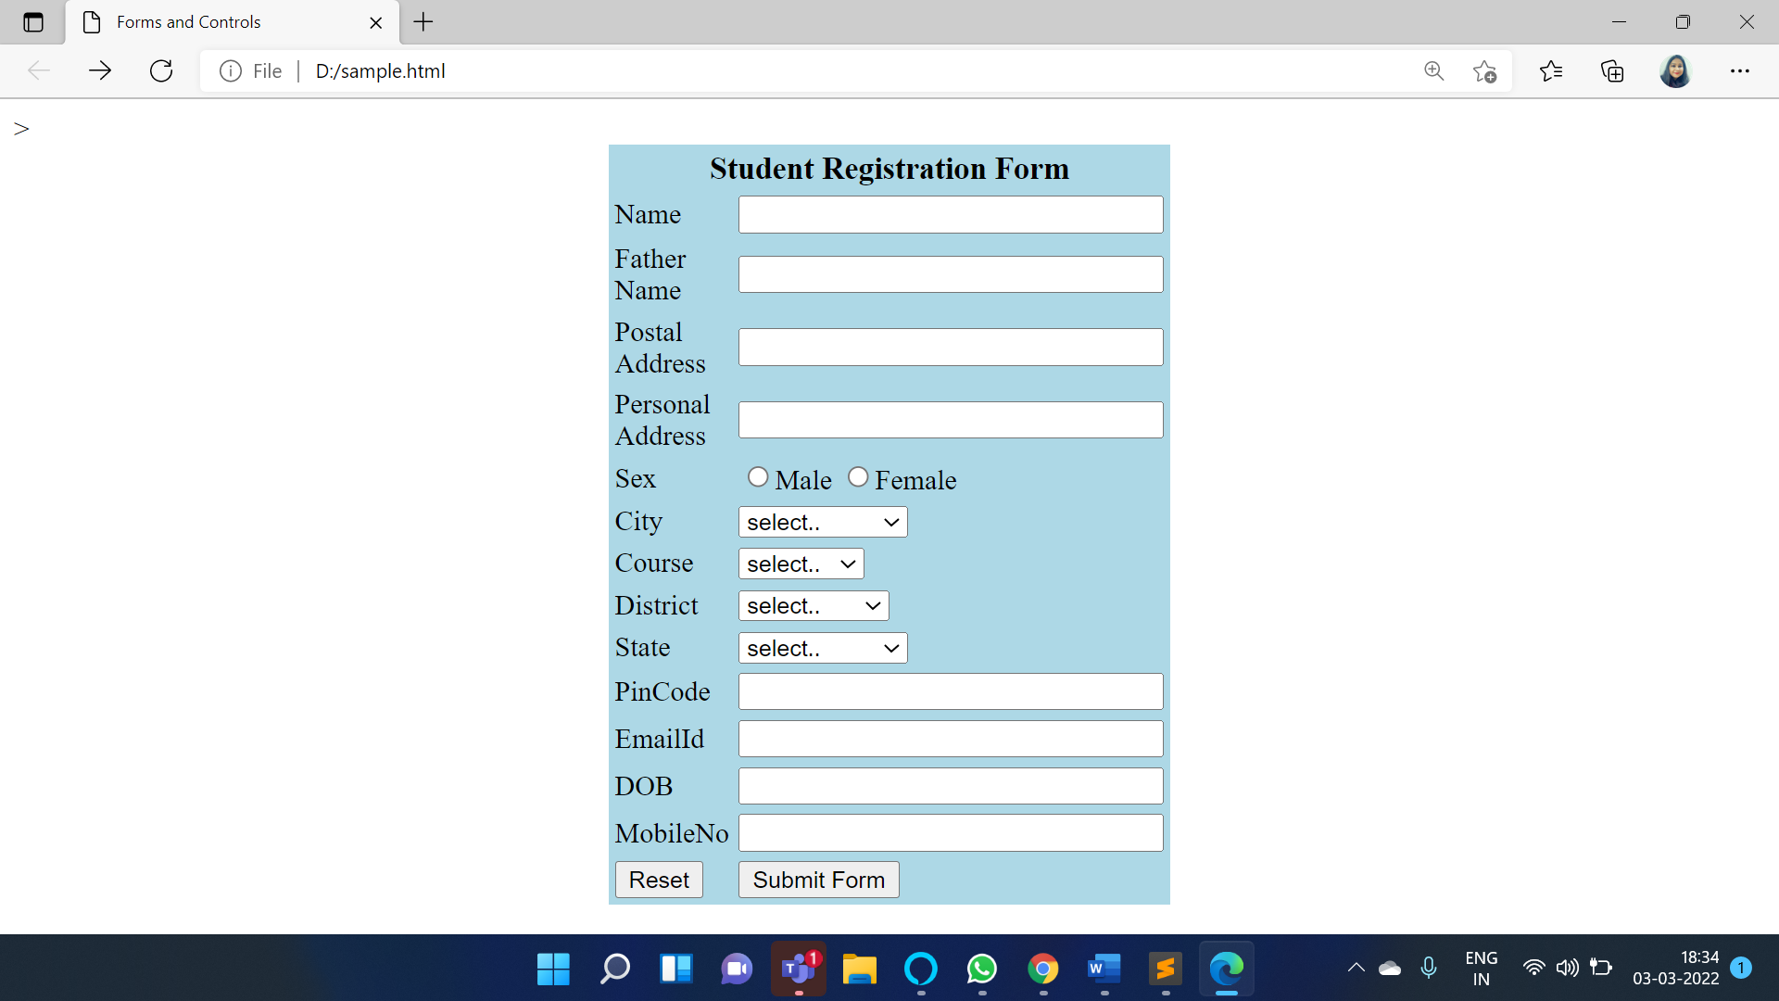

**References:**

* <https://www.tutorialspoint.com/adobe_robohelp/adobe_robohelp_linking_images_multimedia.htm>
* <https://www.scribd.com/document/275188671/Unit-2-Working-with-Links-Images-Forms-and-Multimedia-pdf>

# Activity 6

## Aim: Enable Hypertext Transfer Protocol (HTTP) via GET and POST requests

**Learning outcome:** HyperText MarkUp Language (HTML)

**Duration:** 1 Hr

**List of Hardware/Software requirements:**

1. Windows/Ubuntu OS…...
2. Text Editors- Notepad++, Sublime Text, etc.
3. Browser

**Code/Program/Procedure (with comments):**

<!DOCTYPE html>

<html>

<head>

<title>Get </title>

</head>

<!--Body content Starts-->

<body>

<form action="action_page.php" method="get" target="_blank">

Name: <input type="text" name="fname" size="20"></br></br>

Age: <input type="text" name="age" size="20"></br><br>

<!--Click on the submit button, and the input will be sent to a page on the server called

"/action_page.php".-->

<input type="submit" value="Submit">

</form>

<p>Click on the submit button, and the input will be sent to a page on the server called

"/action_page.php".</p>

</body>

<!--Body content Ends-->

</html>

<!DOCTYPE html>

<html>

<head>

<title>Post </title>

</head>

<!--Body content Starts-->

<body>

<form action="action_page.php" method="post" target="_blank">

Name: <input type="text" name="fname" size="20"></br><br>

Age:<input type="text" name="age" size="20"></br></br>

<!--Click on the submit button, and the form will be submitted using the POST method.-->

<input type="submit" value="Submit">

</form>

<p>Click on the submit button, and the form will be submitted using the POST method.</p>

</body>

<!--Body content Ends-->

</html>

**action_page.php**

<?php

if( isset($_GET["fname"]) && isset($_GET["age"] ))

{

//Display Name and Age in Get Method

echo "Welcome ". $_GET['fname']. "<br />";

echo "You are ". $_GET['age']. " years old.";

exit();

}

?>

<?php

if( isset($_POST["fname"]) && isset($_POST["age"] ))

{

//Display Name and Age in POST Method

echo "Welcome ". $_POST['fname']. "<br />";

echo "You are ". $_POST['age']. " years old.";

exit();

}

?>

**Output/Results snippet:**

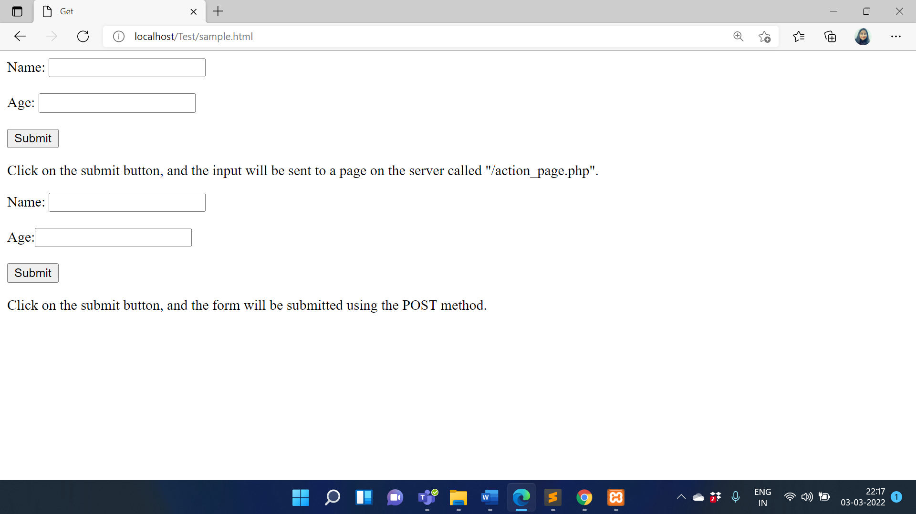

GET Method URL

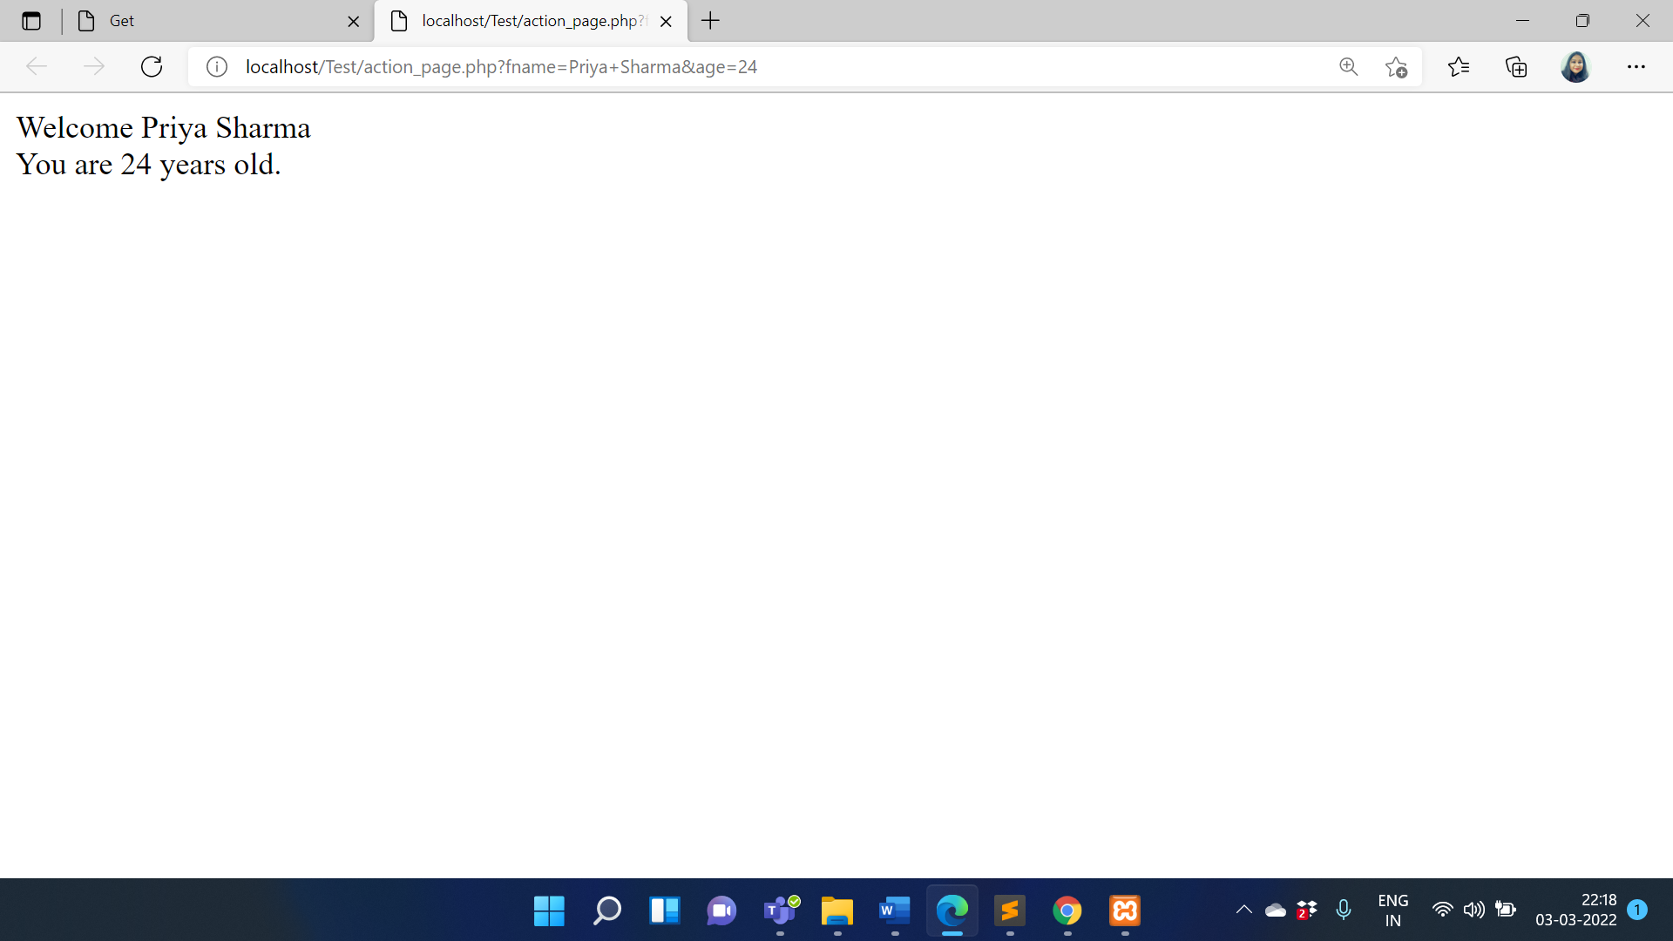

POST Method URL

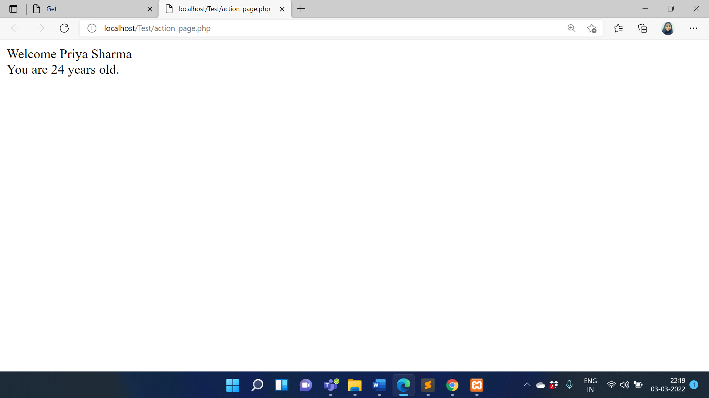

**References:**

* <https://www.guru99.com/php-forms-handling.html>

# Activity 7

## Aim: Obtain input from users.

**Learning outcome:** HyperText MarkUp Language (HTML)

**Duration:** 5 Hrs

**List of Hardware/Software requirements:**

1. Windows/Ubuntu OS…...
2. Text Editors- Notepad++, Sublime Text, etc.
3. Browser

**Code/Program/Procedure (with comments):**

**users.html**

<html>

<head>

<title> Users </title>

</head>

<!--Body Content Starts-->

<body>

<form action="retrieve.php" method="post">

Username: <input type="text" name="username" value="" /></br><br>

Password: <input type="password" name="password" value= "" /></br><br>

<!--If you click the "Submit" button, the form-data will be sent to a page called

"/retrieve.php"-->

<input type="submit" name="submit" value="Submit" />

<p>If you click the "Submit" button, the form-data will be sent to a page called

"/retrieve.php".</p>

</form>

</body>

<!--Body Content Ends-->

</html>

**retrieve.php**

<?php

//Display user Details

echo "<pre>";

print_r($_POST);

echo "</pre>";

echo "Username : {$_POST['username']}<br>";

echo "Password : {$_POST['password']}";

?>

**Output/Results snippet:**

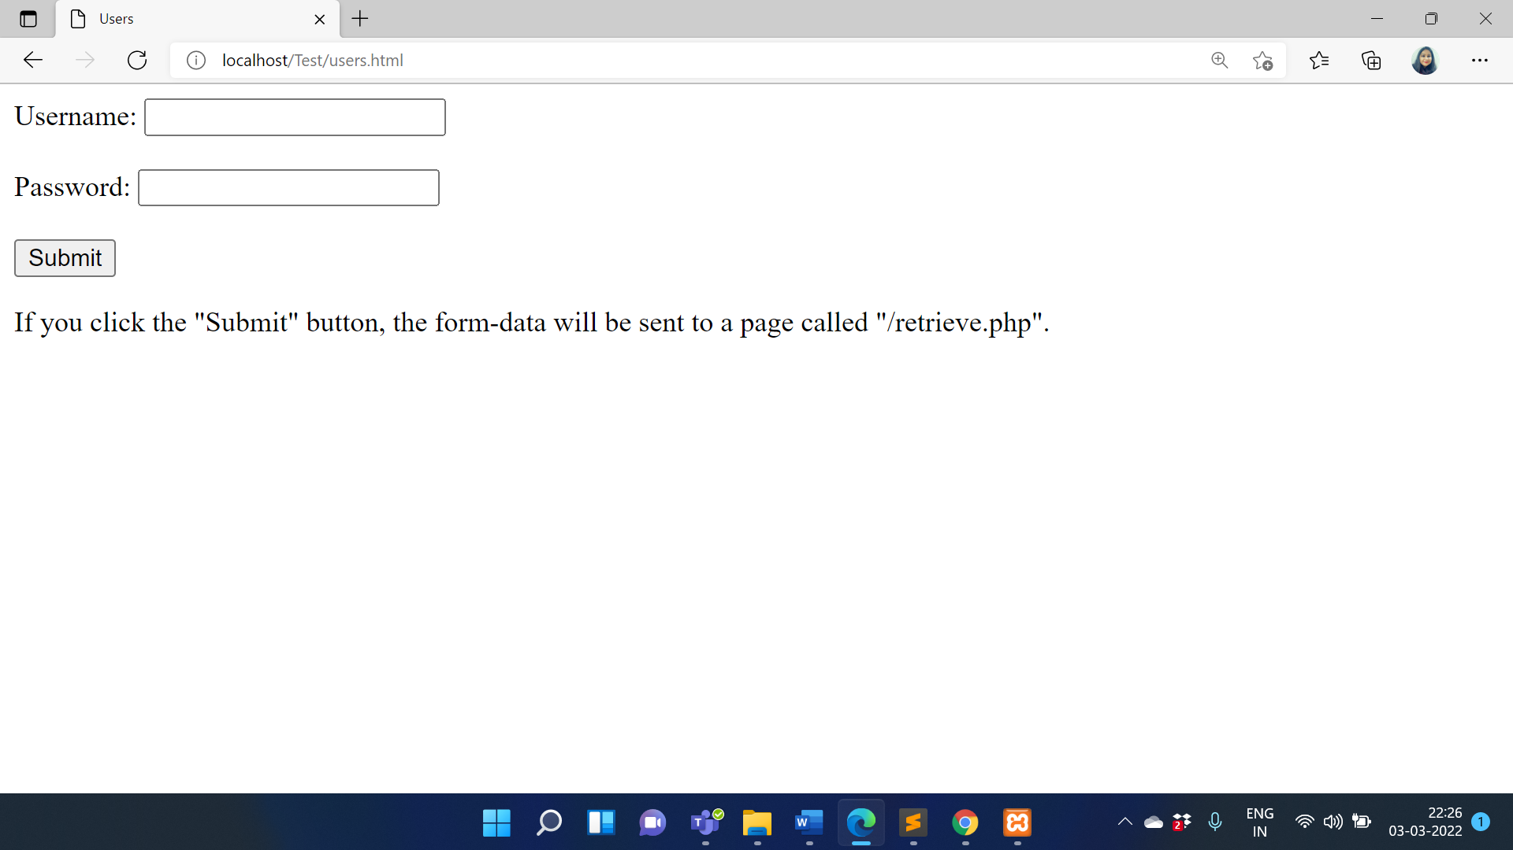

**Obtain User Details**

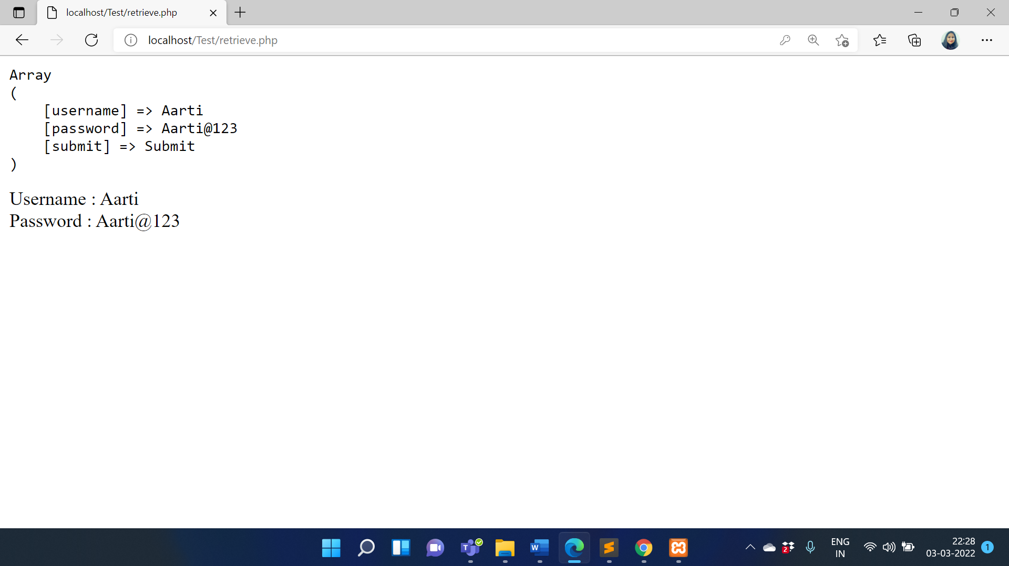

**References:**

* <https://www.programming-techniques.com/2012/02/php-tutorial-getting-user-input-in-php-using-html-form.html>

# Activity 8

## Aim: Divide a webpage into logical sections

**Learning outcome:** HyperText MarkUp Language (HTML)

**Duration:** 1 Hr

**List of Hardware/Software requirements:**

1. Windows/Ubuntu OS…...
2. Text Editors- Notepad++, Sublime Text, etc.
3. Browser

**Code/Program/Procedure (with comments):**

**divide.html**

<!DOCTYPE html>

<html>

<head>

<meta charset="utf-8">

<title>My page title</title>

<link href="https://fonts.googleapis.com/css?family=Open+Sans+Condensed:300|Sonsie+One"

rel="stylesheet" type="text/css">

<link rel="stylesheet" href="style.css">

<!-- the below three lines are a fix to get HTML5 semantic elements working in old versions of

Internet Explorer-->

<script src="https://cdnjs.cloudflare.com/ajax/libs/html5shiv/3.7.3/html5shiv.js"></script>

</head>

<body>

<!-- Here is our main header that is used across all the pages of our website -->

<!-- Header Starts-->

<header>

<h1>Header</h1>

</header>

<!--Header Ends-->

<!--Navigation Menu Starts-->

<nav>

<ul>

<li><a href="#">Home</a></li>

<li><a href="#">Our team</a></li>

<li><a href="#">Projects</a></li>

<li><a href="#">Contact</a></li>

</ul>

<!-- A Search form is another common non-linear way to navigate through a website. -->

<form>

<input type="search" name="q" placeholder="Search query">

<input type="submit" value="Go!">

</form>

</nav>

<!--Navigation Menu Ends-->

<!-- Here is our page's main content -->

<main>

<!-- It contains an article -->

<article>

<h2>Article heading</h2>

<p>Lorem ipsum dolor sit amet, consectetur adipisicing elit. Donec a diam lectus. Set sit

amet ipsum mauris. Maecenas congue ligula as quam viverra nec consectetur ant hendrerit.

Donec et mollis dolor. Praesent et diam eget libero egestas mattis sit amet vitae augue. Nam

tincidunt congue enim, ut porta lorem lacinia consectetur.</p>

<h3>Subsection</h3>

<p>Donec ut librero sed accu vehicula ultricies a non tortor. Lorem ipsum dolor sit amet,

consectetur adipisicing elit. Aenean ut gravida lorem. Ut turpis felis, pulvinar a semper sed,

adipiscing id dolor.</p>

<p>Pelientesque auctor nisi id magna consequat sagittis. Curabitur dapibus, enim sit amet elit

pharetra tincidunt feugiat nist imperdiet. Ut convallis libero in urna ultrices accumsan. Donec sed

odio eros.</p>

<h3>Another subsection</h3>

<p>Donec viverra mi quis quam pulvinar at malesuada arcu rhoncus. Cum soclis natoque

penatibus et magnis dis parturient montes, nascetur ridiculus mus. In rutrum accumsan ultricies.

Mauris vitae nisi at sem facilisis semper ac in est.</p>

<p>Vivamus fermentum semper porta. Nunc diam velit, adipscing ut tristique vitae sagittis

vel odio. Maecenas convallis ullamcorper ultricied. Curabitur ornare, ligula semper consectetur

sagittis, nisi diam iaculis velit, is fringille sem nunc vet mi.</p>

</article>

<!-- the aside content can also be nested within the main content -->

<aside>

<h2>Related</h2>

<ul>

<li><a href="#">Oh I do like to be beside the seaside</a></li>

<li><a href="#">Oh I do like to be beside the sea</a></li>

<li><a href="#">Although in the North of England</a></li>

<li><a href="#">It never stops raining</a></li>

<li><a href="#">Oh well...</a></li>

</ul>

</aside>

</main>

<!-- And here is our main footer that is used across all the pages of our website -->

<footer>

<p> ©Copyright 2020 All rights Reserved.</p>

</footer>

</body>

</html>

**style.css**

html, body {

margin: 0;

padding: 0;

}

html {

font-size: 10px;

background-color: #a9a9a9;

}

body {

width: 70%;

margin: 0 auto;

}

/* || typography */

h1, h2, h3 {

font-family: 'Sonsie One', cursive;

color: #2a2a2a;

}

p, input, li {

font-family: 'Open Sans Condensed', sans-serif;

color: #2a2a2a;

}

h1 {

font-size: 4rem;

text-align: center;

color: white;

text-shadow: 2px 2px 10px black;

}

h2 {

font-size: 3rem;

text-align: center;

}

h3 {

font-size: 2.2rem;

}

p, li {

font-size: 1.6rem;

line-height: 1.5;

}

/* || header layout */

nav, article, aside, footer {

background-color: white;

padding: 1%;

}

nav {

height: 50px;

background-color: #ff80ff;

display: flex;

margin-bottom: 10px;

}

nav ul {

padding: 0;

list-style-type: none;

flex: 2;

display: flex;

}

nav li {

display: inline;

text-align: center;

flex: 1;

}

nav a {

display: inline-block;

font-size: 2rem;

text-transform: uppercase;

text-decoration: none;

color: black;

}

nav form {

flex: 1;

display: flex;

align-items: center;

height: 100%;

padding: 0 2em;

}

input {

font-size: 1.6rem;

height: 32px;

}

input[type="search"] {

flex: 3;

}

input[type="submit"] {

flex: 1;

margin-left: 1rem;

background: #333;

border: 0;

color: white;}

/* || main layout */

main {

display: flex;

}

article {

flex: 4;

}

aside {

flex: 1;

margin-left: 10px;

background-color: #ff80ff;

}

aside li {

padding-bottom: 10px;

}

footer {

margin-top: 10px;

}

**Output/Results snippet:**

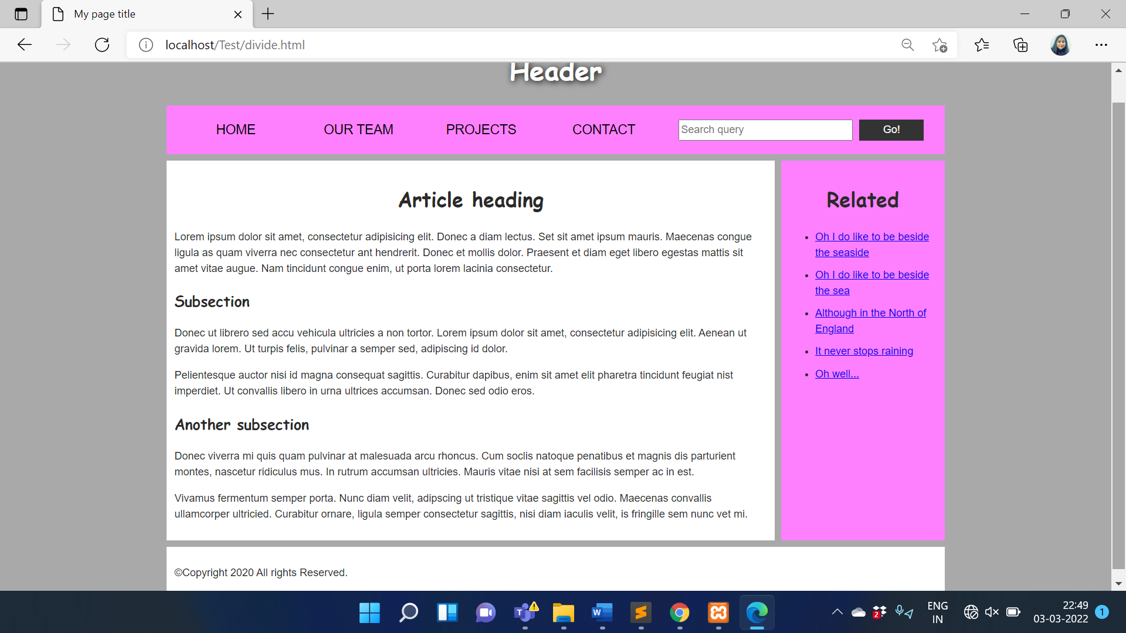

**References:**

* <https://developer.mozilla.org/enUS/Learn/HTML/Howto/Divide_a_webpageinto_logical_sections>

# Activity 9

## Aim: Display computer code with HTML

**Learning outcome:** HyperText MarkUp Language (HTML)

**Duration:** 1 Hr

**List of Hardware/Software requirements:**

1. Windows/Ubuntu OS…...
2. Text Editors- Notepad++, Sublime Text, etc.
3. Browser

**Code/Program/Procedure (with comments):**

<!DOCTYPE html>

<html>

<head>

<title>Code in HTML</title>

<body>

<h2>Computer Code</h2>

<p style="font-weight: bolder;">Some programming code:</p>

<!--Computer Code Starts-->

<code>

x = 5;</br>

y = 6;</br>

z = x + y;

</code>

<!--Computer Code Ends-->

<p style="font-weight: bolder;">C programming code:</p>

<!--Computer Code Starts-->

<pre>

<code>

//C Programming Code

#include<stdio.h>

int main() {

printf("Hello...");

}

</code>

</pre>

<!--Computer Code Ends>

</body>

</html>

**Output/Results snippet:**

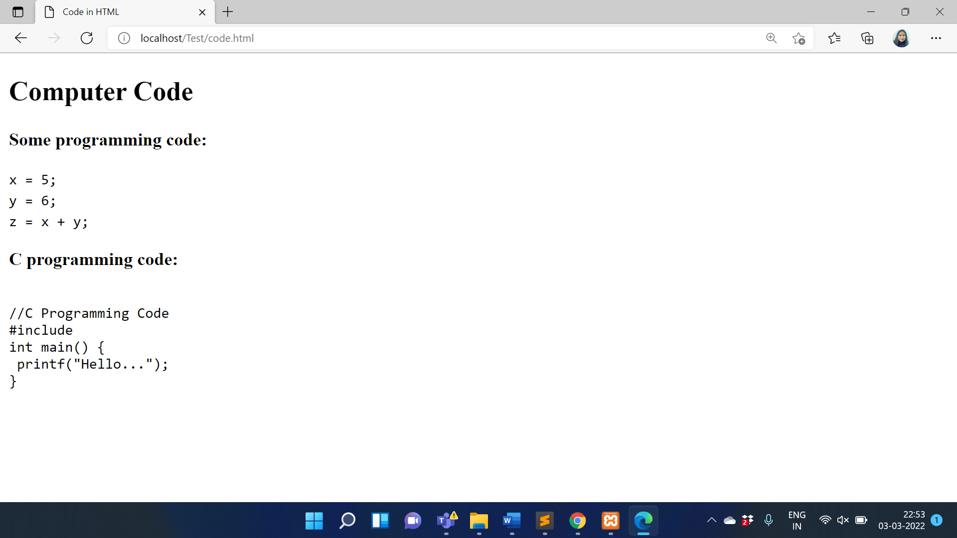

**References:**

* <https://www.geeksforgeeks.org/html-computer-code-elements/>

# Activity 10

## Aim: Annotation of images and graphics.

**Learning outcome:** HyperText MarkUp Language (HTML)

**Duration:** 2 Hrs

**List of Hardware/Software requirements:**

1. Windows/Ubuntu OS…...
2. Text Editors- Notepad++, Sublime Text, etc.
3. Browser

**Code/Program/Procedure (with comments):**

<!DOCTYPE HTML>

<html>

<style>

figure{border: 2px solid black;border-style:ridge;}

figcaption{font-family:Arial; padding:10px; background:#fa4b2a; color:#fff;}

</style>

<body>

<!--single Image-->

<figure>

<img src="nature.jpg"

alt="Nature"

height="300" width="1265"/> <br>

<figcaption>

The view is tree-mendous!

</figcaption>

</figure>

<!--Multiple Images-->

<figure>

<img src="images1.jpg" alt="maina" height="300" width="300"/>

<img src="image2.jpg" alt="kuruvi" height="300" width="300"/>

<img src="image3.jpg" alt="humming" height="300" width="300"/>

<img src="image4.jpg" alt="parrot" height="300" width="336"/>

<figcaption>A forest bird never wants a cage.</figcaption>

</figure>

</body>

</html>

**Output/Results snippet:**

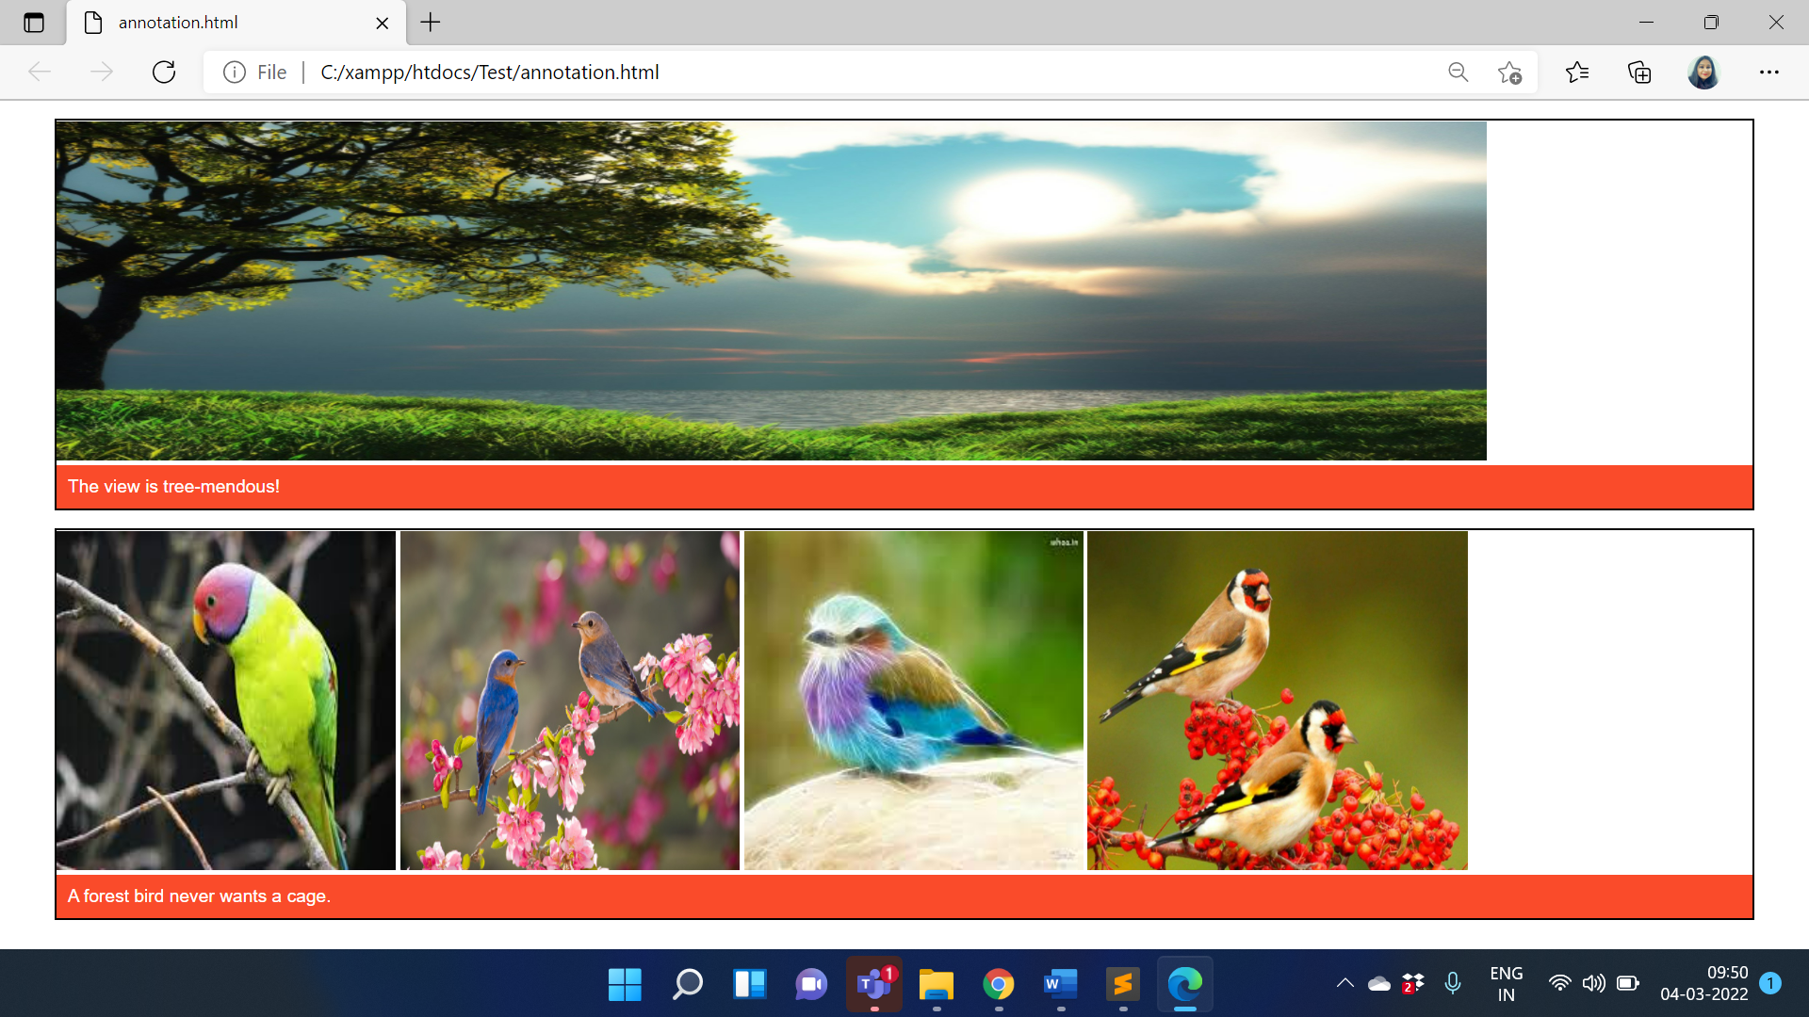

**References:**

* <https://developer.mozilla.org/enUS/docs/Learn/HTML/Multimedia_and_embedding/Images_in_HTML>

# Activity 11

## Aim: Marking abbreviations

**Learning outcome:** HyperText MarkUp Language (HTML)

**Duration:** 1 Hr

**List of Hardware/Software requirements:**

1. Windows/Ubuntu OS…...
2. Text Editors- Notepad++, Sublime Text, etc.
3. Browser

**Code/Program/Procedure (with comments):**

<!DOCTYPE html>

<html>

<body>

<p>The <abbr title="World Health Organization">WHO</abbr> was founded in 1948.</p>

</body>

</html>

**Output/Results snippet:**

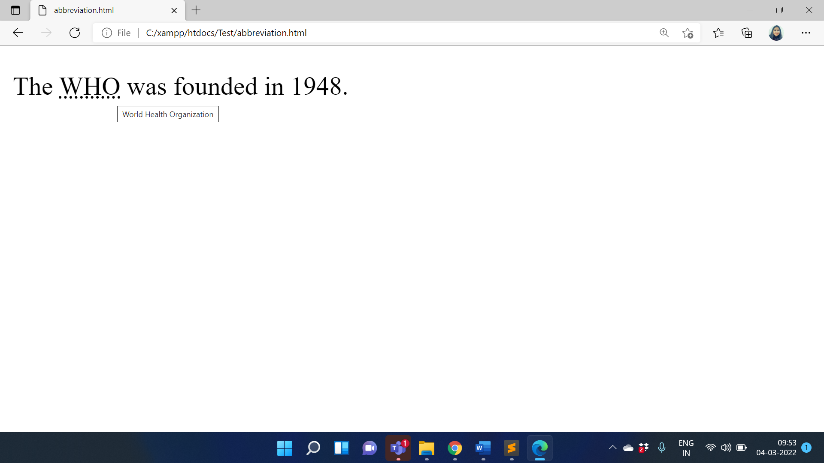

**References:**

* <https://www.w3schools.com/tags/tag_abbr.asp>
* <https://developer.mozilla.org/en-US/docs/Web/HTML/Element/abbr>

# Activity 12

## Aim: Add quotations and citations to web pages

**Learning outcome:** HyperText MarkUp Language (HTML)

**Duration:** 2 Hrs

**List of Hardware/Software requirements:**

1. Windows/Ubuntu OS…...
2. Text Editors- Notepad++, Sublime Text, etc.
3. Browser

**Code/Program/Procedure (with comments):**

<!DOCTYPE html>

<html>

<body>

<p>Here is a quote from WWF's website:</p>

<blockquote cite="http://www.worldwildlife.org/who/index.html">

For 50 years, WWF has been protecting the future of nature.

The world's leading conservation organization,

WWF works in 100 countries and is supported by

1.2 million members in the United States and

close to 5 million globally.

</blockquote>

</body>

</html>

**Output/Results snippet:**

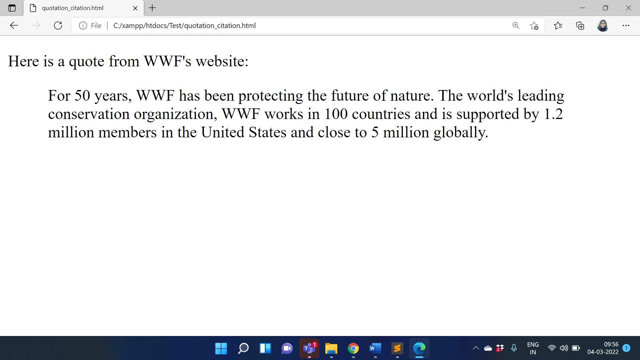

**References:**

* <https://www.geeksforgeeks.org/html-quotations/>
* <https://www.w3schools.com/html/html_quotation_elements.asp>

# Activity 13

## Aim: Embed a webpage within another webpage

**Learning outcome:** HyperText MarkUp Language (HTML)

**Duration:** 2 Hrs

**List of Hardware/Software requirements:**

1. Windows/Ubuntu OS…...
2. Text Editors- Notepad++, Sublime Text, etc.
3. Browser

**Code/Program/Procedure (with comments):**

<!DOCTYPE html>

<html>

<body>

<iframe src="https://en.wikipedia.org/wiki/HTML">

<p>Your browser does not support iframes.</p>

</iframe>

</body>

</html>

**Output/Results snippet:**

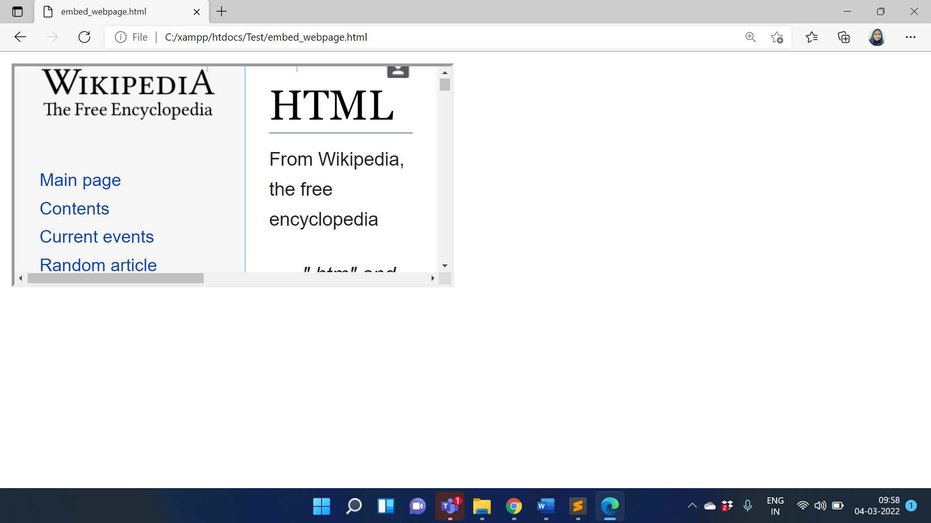

**References:**

* <https://atomisystems.com/html5-animation/embedding-html5-project-into-webpage/>
* <https://www.tutorialrepublic.com/html-tutorial/html-iframes.php>